**A PROJECT REPORT**

**on**

**“SIGNIFY – Sign Language Detector”**

***Dissertation submitted to***

***Shri Ramdeobaba College of Engineering & Management, Nagpur in partial fulfillment of requirement for the award of degree of***

**Bachelor of Technology (B.Tech)**

In

**COMPUTER SCIENCE AND ENGINEERING**

(Artificial Intelligence & Machine Learning)

***Submitted by***

**Tanmay Sayare (Roll no .67)**

**Nandini Giri (Roll no .68)**

*Guide*

**Prof. Pranali Dandekar**



#### **Department of Computer Science and Engineering (Artificial Intelligence & Machine Learning)**

**Shri Ramdeobaba College of Engineering & Management, Nagpur 440 013**

(An Autonomous Institute aﬃliated to Rashtrasant Tukdoji Maharaj Nagpur University Nagpur)

#### April 2025

**SHRI RAMDEOBABA COLLEGE OF ENGINEERING MANAGEMENT, NAGPUR**

(An Autonomous Institute aﬃliated to Rashtrasant Tukdoji Maharaj Nagpur University Nagpur)

**Department of Computer Science and Engineering**

(Artificial Intelligence & Machine Learning)

## CERTIFICATE

This is to certify that the Thesis on **“ SIGNIFY – Sign Language Detector ”** is a Bonafide work of

1. Tanmay Sayare
2. Nandini Giri

submitted to the Rashtrasant Tukdoji Maharaj Nagpur University, Nagpur in partial fulfillment of the award of a Degree of Bachelor of Technology (B.Tech), in Computer Science and Engineering (Artificial Intelligence & Machine Learning). It has been carried out at the Department of Computer Science and Engineering, Shri Ramdeobaba College of Engineering and Management, Nagpur during the academic year 2025-2026.

Date:

Place: Nagpur

Prof . Pranali Dandekar Dr. P. Voditel

Project Guide H.O.D, CSE

Dr. M. B. Chandak Principal

## DECLARATION

We hereby declare that the thesis titled “**Traffic Sign Recognition Using Machine Learning**” submitted herein, has been carried out in the Department of Computer Science and Engineering (Artificial Intelligence and Machine Learning) of Shri Ramdeobaba College of Engineering and Management, Nagpur. The work is original and has not been submitted earlier as a whole or part for the award of any degree/diploma at this or any other institution / University.

#### **Name of the Student Signature**

Tanmay Sayare

Nandini Giri

Date:

Place: Nagpur

## APPROVAL SHEET

This report entitled “**Signify – Sign Language Detector** ” by

1. Tanmay Sayare
2. Nandini Giri

,is approved for the degree of Bachelor of Technology (B.Tech).

Prof. Pranali Dandekar

Project Guide

CSE

Date:

Place: Nagpur

## ACKNOWLEDGEMENTS

Today, on the completion of this project, we owe our deepest gratitude to the people who

have supported us throughout the making of this project dissertation. Without their guidance and encouragement, this project would not have seen the light of day.

Primarily, we submit our sincere thanks and gratitude to our guide **prof . Pranali Dandekar** for her constant motivation and support during the project. Her esteemed guidance and encouragement from the beginning to the end of this project have been invaluable. We are also deeply thankful to **Dr. M.B. Chandak**, principal of our college, for encouraging us and fostering a healthy environment in which to learn in the best possible way. Additionally, we extend our heartfelt thanks to **Dr. P. Voditel**, Head of the Department, for her unwavering moral support and motivation during the entire course of the project.

We would like to thank all the staff members and technicians of our college for their help in making this project a success.

1. Tanmay Sayare (Roll No. 67)
2. Nandini Giri (Roll No. 68)

## ABSTRACT :

Effective communication is essential for meaningful human interaction, yet it remains a challenge for the hearing-impaired community due to the limited understanding of sign language by the general population. This project presents an innovative solution: a **Sign Language Detector** that utilizes **deep learning and Python** to bridge the communication gap between sign language users and non-users.

The system integrates **Mediapip**e and Landmark modules for real-time hand tracking and gesture detection, ensuring precise identification of hand movements. A **Random Forest algorithm** is employed to classify and recognize these gestures accurately, translating them into spoken or written language. This enables seamless, real-time interaction and promotes inclusivity in various social and professional settings.

Designed with a user-friendly interface, the translator is accessible to a broad audience, including individuals with limited technical knowledge. The system also offers adaptability to different sign languages, increasing its global relevance and impact.

By combining the power of computer vision, machine learning, and intuitive design, this project significantly contributes to the advancement of assistive technologies. It not only enhances communication accessibility but also fosters a more inclusive and understanding society for the hearing-impaired community.

# Introduction

## ​Introduction

Effective communication is a fundamental aspect of human interaction, enabling us to convey thoughts, emotions, and ideas. However, for the hearing-impaired community, conventional modes of communication may present significant challenges. Sign language serves as a vital means of expression for these individuals, but it remains a barrier for the broader population due to its complexity and lack of widespread understanding.

This project aims to address this communication gap by introducing a groundbreaking solution: the **Sign Language Detector using deep learning and Pytho**n, incorporating the powerful **Mediapipe, Landmark, and Random Forest modules**. The primary objective of this project is to develop a system that can accurately translate sign language gestures into spoken or written language, facilitating seamless communication between the hearing-impaired community and the rest of the world.

Machine learning, a subfield of artificial intelligence, has demonstrated remarkable capabilities in pattern recognition and language processing. By leveraging the power of machine learning algorithms and Python programming, this project endeavors to enable the efficient and accurate interpretation of complex hand gestures in real-time.

The integration of the Mediapipe library and the Landmark module significantly enhances the system's capabilities. These modules allow for precise hand landmark detection and real-time hand tracking, which are crucial for recognizing and understanding sign language gestures accurately.

Additionally, the Random Forest algorithm, known for its versatility and robustness, is employed to construct a reliable sign language recognition model. By combining these advanced technologies, the Sign Language Translator can achieve high accuracy and provide a user-friendly experience for both the hearing-impaired and non-sign language users.

The development of this project has been guided by an experienced mentor, ensuring the project's direction and success. Furthermore, the support and resources provided by the faculty at LDRP-ITR have been invaluable in bringing the project to fruition.

Through this innovative project, we aspire to contribute to the improvement of communication accessibility and inclusivity for the hearing-impaired community. The Sign Language Translator represents a significant step forward in assistive technology, making sign language more understandable and accessible to a broader audience. In the following sections, we will delve into the technical aspects and implementation details of the Sign Language Translator, exploring how machine learning, Python, and the Mediapipe, Landmark, and Random Forest modules synergistically work together to achieve this transformative goal.

## ​Scope

The Sign Language Translator project using machine learning and Python with the integration of Mediapipe, Landmark, and Random Forest modules holds immense potential to address critical communication challenges faced by the hearing-impaired community. The scope of this project extends to various dimensions, encompassing technical advancements, societal impact, and future developments.

1. Communication Accessibility: The primary scope of the Sign Language Translator is to enhance communication accessibility for the hearing-impaired. By accurately translating sign language gestures into spoken or written language, the system facilitates seamless interactions between individuals proficient in sign language and those who are not. This inclusivity in communication has the potential to positively impact various aspects of everyday life, including education, employment, and social interactions.
2. Real-time Recognition: The incorporation of the Mediapipe and Landmark modules enables real-time hand tracking and precise landmark detection. This scope opens up possibilities for real-time translation of sign language gestures during live conversations, presentations, or events, making the system useful in dynamic and interactive settings.
3. User-friendly Interface: The project aims to create a user-friendly interface for both hearing-impaired and non-sign language users. An intuitive and easy-to-use interface enhances the usability and adoption of the Sign Language Translator, making it accessible to a wider audience.
4. Accuracy and Robustness: Leveraging the Random Forest algorithm, the project strives to build a reliable and robust sign language recognition model. Ensuring high accuracy in

gesture recognition is crucial for the effective functioning of the translator, and it broadens its potential applications in diverse scenarios.

1. Adaptability to Diverse Sign Languages: The project's scope extends to developing a system that can be adapted to various sign language systems across different regions. By training the model with datasets encompassing various sign languages, the translator can cater to the unique gestures and signs used by different communities.
2. Assistive Technology Integration: The Sign Language Translator can be integrated into various assistive technology devices and applications. This integration expands the scope of its applications, making it accessible through smartphones, tablets, and other wearable devices, further enhancing communication accessibility on multiple platforms.
3. Research and Development: The project's exploration into machine learning, computer vision, and Python programming with the integration of Mediapipe, Landmark, and Random Forest modules paves the way for future research and development in the domain of sign language recognition and translation.

## ​Project summary and Purpose

The Sign Language Translator project aims to develop an innovative communication tool using machine learning and Python, integrated with the powerful Mediapipe, Landmark, and Random Forest modules. The project focuses on bridging the communication gap between the hearing-impaired community and the rest of the world by accurately translating sign language gestures into spoken or written language. By harnessing the capabilities of machine learning and computer vision, the project endeavors to create a user-friendly and real-time translation system that facilitates seamless interactions between sign language users and non-sign language users.

The development of the Sign Language Translator is guided by an experienced mentor and supported by the faculty members of [Your University/Institution Name], ensuring a well-structured and successful implementation. The project encompasses cutting-edge technologies, including real-time hand tracking and landmark detection provided by Mediapipe

and Landmark modules, combined with the robustness of the Random Forest algorithm for sign language recognition.

## Purpose:

The purpose of the Sign Language Translator project is twofold: to enhance communication accessibility for the hearing-impaired community and to promote inclusivity in society.

1. **Enhancing Communication Accessibility:** The project's primary purpose is to create an effective tool that enables the hearing-impaired community to communicate more effortlessly with non-sign language users. By converting sign language gestures into spoken or written language, the translator provides a seamless means of interaction, improving access to education, employment, and social engagement for the hearing-impaired.
2. **Promoting Inclusivity:** The Sign Language Translator contributes to fostering a more inclusive society by breaking down communication barriers between different linguistic communities. By providing a bridge between sign language and spoken/written language, the translator promotes understanding, empathy, and collaboration, creating an environment where all individuals can communicate and connect effectively.
3. **Technological Advancement:** The project serves as a platform for exploring the potential of machine learning, computer vision, and Python programming in the domain of sign language recognition and translation. Through the integration of advanced modules like Mediapipe, Landmark, and Random Forest, the project showcases the possibilities of technology in addressing real-world challenges faced by diverse communities.
4. **Research and Academic Excellence:** The Sign Language Translator project contributes to academic excellence by delving into innovative techniques and methodologies. The exploration of cutting-edge technologies and the development of a functional translator can open doors to further research and advancements in the field of assistive technology and accessibility.
5. **Impact on Society:** By providing an effective means of communication for the hearing-impaired community, the Sign Language Translator has the potential to positively impact society at large. It encourages an inclusive approach to communication and promotes a more understanding and supportive environment for people with diverse communication needs.

In conclusion, the Sign Language Translator project holds great significance in its purpose to enhance communication accessibility, promote inclusivity, and explore the possibilities of technology in addressing real-world challenges. Through its innovative approach and technical prowess, the project seeks to make a positive impact on the lives of the hearing-impaired community and foster a more inclusive and connected society.

## ​Overview of the project

The Sign Language Translator using machine learning and Python with the integration of Mediapipe, Landmark, and Random Forest modules is a cutting-edge project that addresses the crucial need for enhanced communication accessibility for the hearing-impaired community. This project aims to develop a user-friendly system that accurately translates sign language gestures into spoken or written language, enabling seamless communication between sign language users and the rest of the world.

The project's foundation lies in the application of machine learning, a subset of artificial intelligence, which excels in pattern recognition and language processing. By leveraging machine learning algorithms and Python programming, the system can effectively interpret complex hand gestures and convert them into understandable language.

To achieve precise hand gesture recognition, the project integrates two powerful modules: Mediapipe and Landmark. The Mediapipe library allows for real-time hand tracking, while the Landmark module enables the detection of critical hand landmarks. These functionalities play a pivotal role in accurately capturing the nuances of sign language gestures, ensuring the translation process is both swift and accurate.

To construct a reliable and robust sign language recognition model, the project utilizes the Random Forest algorithm. This versatile algorithm effectively handles complex data and improves the accuracy of the system's translations.

The project's development is guided by an experienced mentor, ensuring that the project follows a well-structured approach and reaches its objectives efficiently. Additionally, the support and resources provided by the faculty at LDRP-ITR contribute significantly to the project's progress and academic excellence.

The Sign Language Translator aims to be adaptable to various sign languages, making it relevant and accessible to diverse communities. The system's user-friendly interface ensures ease of use for both hearing-impaired individuals and non-sign language users, promoting inclusivity in communication.

The potential societal impact of the project is far-reaching. By breaking down communication barriers, the Sign Language Translator fosters understanding and empathy towards the hearing-impaired community, leading to a more inclusive and compassionate society. Furthermore, its integration into various assistive technology devices and applications enhances its usability and accessibility.

Throughout the project report, we will delve into the technical intricacies of machine learning, Python programming, and the functionalities of the Mediapipe, Landmark, and Random Forest modules. We will also discuss the challenges encountered during development and the strategies employed to overcome them.

## 1.4 Problem definition

The Sign Language Translator project addresses a significant communication challenge faced by the hearing-impaired community. The primary problem is the lack of effective communication between individuals proficient in sign language and those who are not. Sign language, though a powerful mode of expression for the deaf and hard-of-hearing, remains largely unintelligible to the broader population due to its complexity and limited understanding.

The main problem can be broken down into several key aspects:

1. **Communication Gap:** The hearing-impaired individuals often face difficulties in effectively communicating with people who do not understand sign language. This communication gap can lead to social isolation, limited educational opportunities, and reduced access to essential services.
2. **Limited Accessibility:** While there are sign language interpreters and tools available for translation, they may not always be readily accessible or available in various situations. This limitation hinders effective communication in real-time scenarios.
3. **Complex Gesture Recognition:** Sign language involves intricate hand gestures and movements, making it challenging for non-sign language users to interpret

and comprehend. Accurate and real-time recognition of these gestures poses a significant technical challenge.

1. **Lack of Inclusivity:** The lack of understanding and familiarity with sign language contributes to a lack of inclusivity in society, hindering meaningful interactions and collaborations between individuals with and without hearing impairments.

The Sign Language Translator project aims to tackle these problems by leveraging the power of machine learning, computer vision, and Python programming. By developing a robust and user-friendly system capable of recognizing and translating sign language gestures in real-time, the project seeks to bridge the communication gap and promote inclusivity for the hearing-impaired community.

In conclusion, the problem definition for the Sign Language Translator project revolves around creating an innovative solution to overcome communication barriers faced by the hearing-impaired community. By addressing the challenges of gesture recognition and real-time translation, the project endeavors to create a transformative tool that promotes communication accessibility and inclusivity for all.

# Technology and Literature Review

## ​About Tools and Technology

The development of the Sign Language Translator project using machine learning and Python with the integration of Mediapipe, Landmark, and Random Forest modules requires a combination of cutting-edge tools and technologies. These tools play a vital role in facilitating the accurate recognition of sign language gestures and enabling seamless communication between the hearing-impaired and non-sign language users. The key tools and technologies utilized in this project are as follows:

1. **Python:** Python programming language serves as the core foundation for developing the Sign Language Translator. Its simplicity, versatility, and extensive libraries make it an ideal choice for implementing machine learning algorithms, handling data, and creating an interactive user interface.
2. **Machine Learning:** Machine learning techniques form the backbone of the project, allowing the system to recognize and interpret sign language gestures accurately. By training the model on relevant datasets, the machine learning algorithms can generalize patterns and recognize new signs.
3. **Mediapipe:** Mediapipe is a powerful computer vision library developed by Google that offers various pre-built solutions for vision-based tasks. In this project, the library is used for real-time hand tracking and landmark detection, providing the critical foundation for recognizing sign language gestures.
4. **Landmark Module:** The Landmark module, an integral part of the Mediapipe library, facilitates the extraction of essential hand landmarks from video data. These landmarks serve as reference points for analyzing hand gestures, contributing to the accuracy of the translation process.
5. **Random Forest Algorithm:** The Random Forest algorithm is employed for building the sign language recognition model. Its ensemble learning approach and ability to handle complex datasets make it well-suited for this project, resulting in a robust and accurate translation system.
6. **Deep Learning Libraries:** Depending on the project's complexity and specific requirements, deep learning libraries like TensorFlow or PyTorch may also be incorporated to enhance the performance of the machine learning models.
7. **User Interface Design:** A user-friendly interface is crucial for ensuring accessibility and ease of use. Technologies like PyQt or Tkinter may be utilized to create interactive graphical interfaces for the Sign Language Translator, enabling seamless communication for both hearing-impaired and non-sign language users.
8. **Data Collection and Preprocessing:** For training the machine learning model, a dataset of sign language gestures is required. The data may be collected from public repositories or generated through data augmentation techniques. Data preprocessing techniques, such as normalization and feature extraction, are also utilized to prepare the data for training.
9. **Version Control:** Tools like Git and GitHub are invaluable for version control and collaboration among team members, ensuring seamless code integration and tracking changes throughout the development process.

In conclusion, the Sign Language Translator project incorporates a range of tools and technologies, including Python, machine learning algorithms, Mediapipe, Landmark, and the Random Forest algorithm, to achieve its goal of bridging the communication gap for the hearing-impaired community. These tools, working in synergy, enable the creation of a powerful and user-friendly translator that has the potential to positively impact the lives of individuals with hearing impairments and promote inclusivity in communication.

## 2.1 Brief History of Work Done

The journey of developing the Sign Language Translator using machine learning and Python, along with the integration of Mediapipe, Landmark, and Random Forest modules, has been one of continuous exploration and innovation. The inception of this project was rooted in the recognition of the challenges faced by the hearing-impaired community in effectively communicating with the rest of the world.

The project commenced with an in-depth study of sign language and its complexities. Understanding the nuances of different sign language systems, including their regional variations, served as a foundation for the subsequent work. Extensive research into machine learning and computer vision algorithms laid the groundwork for identifying the most suitable approaches for accurate sign language recognition.

As the project progressed, the team identified the significance of real-time hand tracking and landmark detection for interpreting sign language gestures with precision. This realization led to the adoption of the Mediapipe and Landmark modules, which played a pivotal role in developing a robust system capable of efficiently capturing and analyzing hand movements.

The integration of the Random Forest algorithm was a critical milestone in the project's history. By harnessing the power of ensemble learning, the team was able to construct a reliable sign language recognition model with high accuracy. Extensive training and testing with diverse datasets were conducted to fine-tune the model and ensure its adaptability to various sign language systems.

Throughout the project's development, the guidance and expertise of the project mentor, Tejasvee Sir, proved invaluable in shaping the project's direction and ensuring best practices in machine learning and computer vision were followed. The mentor's continuous feedback and support motivated the team to overcome challenges and push the boundaries of the project.

The implementation phase involved coding and integrating the modules, creating an intuitive user interface, and conducting extensive testing and debugging to achieve a functional and user-friendly Sign Language Translator.

The project has been enriched by the contributions of the faculty members of LDRP-ITR, Computer Engineering, whose support and resources provided a conducive learning environment and assisted in overcoming technical obstacles.

As the project neared completion, the team took great care to optimize and refine the Sign Language Translator, focusing on usability, accuracy, and adaptability. This iterative process involved continuous feedback and testing from both the hearing-impaired and non-sign language users, enabling the team to make necessary improvements.

In conclusion, the history of work done on the Sign Language Translator project has been one of passion, dedication, and a commitment to inclusivity. From the initial research and technical explorations to the development of a fully functional translator, this project represents a significant step forward in leveraging cutting-edge technologies to improve communication accessibility and bridge the gap between the hearing-impaired community and the world. The project's impact is not only in its innovative approach but also in its potential to foster empathy, understanding, and an inclusive society for all.

# System Requirements Study

## ​User Characteristics

Understanding the characteristics of the users who will interact with the system is vital for conducting a comprehensive system requirements study. User characteristics help in tailoring the design and functionality of the system to meet the specific needs and preferences of the target audience. In the context of the Sign Language Translator project, the following user characteristics are essential to consider:

1. **Hearing-Impaired Individuals:** The primary users of the Sign Language Translator are members of the hearing-impaired community. These individuals rely on sign language as their primary mode of communication. It is crucial to recognize the diversity within this user group, including varying levels of sign language proficiency and preferred signing styles.
2. **Non-Sign Language Users:** Another important user group comprises individuals who are not proficient in sign language but wish to communicate with the hearing-impaired. The system should cater to their needs by accurately translating sign language gestures into spoken or written language.
3. **Technical Proficiency:** Users' technical proficiency varies, ranging from tech-savvy individuals who are comfortable with advanced technology to those with limited experience or familiarity with machine learning applications. The system's user interface should be intuitive and user-friendly to accommodate users across this spectrum.
4. **Real-Time Communication:** For users engaging in real-time conversations, the system's responsiveness and speed are critical. The Sign Language Translator must process and interpret hand gestures promptly to facilitate seamless and natural interactions.
5. **Accessibility Needs:** Some users may have additional accessibility needs, such as visual impairments or motor disabilities. It is essential to ensure that the system's user interface is designed with accessibility features to cater to a diverse range of users.
6. **Language and Cultural Diversity:** The Sign Language Translator may be used by users from various linguistic and cultural backgrounds. The system should be adaptable to different sign languages and be able to accommodate variations in signing gestures that may exist across regions.
7. **Context of Use:** Understanding the typical scenarios in which the system will be used is crucial. The Sign Language Translator might be used in educational settings, social interactions, or professional environments, each with specific requirements that need to be considered during the system design.
8. **Privacy and Security Concerns:** Users might have privacy and security concerns related to the data collected during system usage. Ensuring data privacy and implementing robust

security measures is of utmost importance.

By taking into account these user characteristics, the system requirements study can identify the specific needs and preferences of the target users. This knowledge serves as a foundation for designing an effective and user-centered Sign Language Translator, ultimately enhancing communication accessibility and promoting inclusivity for the hearing-impaired community and beyond.

## ​Hardware and Software Requirements

1. **Hardware Requirements:**
   1. **Computer:** A desktop or laptop computer with adequate processing power and memory is essential for conducting the system requirements study. The computer should meet

the minimum specifications to handle data processing, machine learning algorithms, and computer vision tasks efficiently.

* 1. **Webcam:** A high-quality webcam is required to capture real-time video data for hand tracking and landmark detection. The webcam should have a resolution that allows clear and accurate visualization of hand gestures.
  2. **Graphics Processing Unit (GPU):** While not mandatory, a dedicated GPU with CUDA support can significantly accelerate the machine learning processes, especially when dealing with large datasets or complex models.
  3. **Internet Connectivity:** Internet connectivity is necessary for accessing external libraries, APIs, and resources used during the development of the Sign Language Translator. Additionally, it allows for updates and information retrieval during the research process.

## Software Requirements:

* 1. **Python:** The system requirements study necessitates the use of the Python programming language. Python provides a vast array of libraries and frameworks for machine learning, computer vision, and data processing, making it an ideal choice for this project.
  2. **Python Libraries:** The following Python libraries are crucial for this project:
* Mediapipe: For real-time hand tracking and landmark detection.
* Scikit-learn: For implementing the Random Forest algorithm for sign language recognition.
* OpenCV: For video processing and computer vision tasks.
* Numpy and Pandas: For numerical computations and data manipulation.
* Matplotlib and Seaborn: For data visualization and analysis.
  1. **Integrated Development Environment (IDE):** An IDE such as PyCharm, Visual Studio Code, or Jupyter Notebook is recommended for efficient code development, debugging, and code organization.
  2. **Machine Learning Framework:** Depending on the complexity of the model and the specific requirements, TensorFlow or PyTorch can be utilized for training and deploying machine learning models.
  3. **Operating System:** The project can be developed and executed on various operating systems, including Windows, macOS, or Linux.
  4. **Version Control:** A version control system, such as Git, is recommended to track changes, collaborate with team members, and maintain the project's integrity.
  5. **Documentation Tools:** Tools like LaTeX or Markdown can be used to create project documentation, reports, and presentations.

By meeting the above hardware and software requirements, the system requirements study can be conducted effectively, enabling the successful development and implementation of the Sign Language Translator using machine learning and Python with Modules Mediapipe, Landmark, and Random Forest.

## ​Constraints

* + 1. **​Regulatory Policies:**

1. **Data Protection and Privacy Regulations:** Depending on the nature of the system and the data it processes, there may be specific regulations regarding data protection and user privacy. For instance, the General Data Protection Regulation (GDPR) in Europe or the Health Insurance Portability and Accountability Act (HIPAA) in the United States dictate how personal data should be collected, stored, processed, and shared. Compliance with these regulations ensures the system's responsible handling of sensitive information.
2. **Accessibility Standards:** Accessibility regulations aim to make digital systems inclusive and accessible to all users, including those with disabilities. Following guidelines such as the Web Content Accessibility Guidelines (WCAG) ensures that the system accommodates users with visual, auditory, motor, or cognitive impairments, enabling equal access to information and functionality.
3. **Security and Data Breach Regulations:** Security is paramount in any system to safeguard against data breaches and unauthorized access. Depending on the industry or the sensitivity of data being processed, there may be specific security standards and regulations to comply with, such as the ISO/IEC 27001 for information security management.
4. **Intellectual Property and Copyright Laws:** If the system involves the use of proprietary software, third-party components, or copyrighted materials, it is essential to adhere to intellectual property laws and obtain the necessary permissions and licenses.
5. **Industry-specific Regulations:** Some industries, such as finance, healthcare, and aviation, have specific regulatory requirements that must be met. For instance, financial systems may need to comply with Anti-Money Laundering (AML) regulations, while healthcare systems must adhere to Health Insurance Portability and Accountability Act (HIPAA) guidelines.
6. **Budgetary and Resource Constraints:** The system requirements study must consider budgetary constraints and the availability of resources such as time, skilled personnel, and technology infrastructure. Balancing project goals with available resources is essential to ensure a successful and sustainable implementation.
7. **Scalability and Performance Requirements:** Depending on the expected user base and system usage, scalability and performance constraints should be considered to ensure the system can handle increasing loads without compromising functionality or response times.
8. **Interoperability and Integration Requirements:** If the system needs to interact with existing software or external systems, compatibility and interoperability constraints must be addressed to ensure smooth integration.
9. **Ethical and Social Constraints:** In the development of AI-driven systems, ethical considerations such as bias mitigation, fairness, and transparency should be taken into account to ensure responsible AI usage.
10. **Governmental and Local Regulations:** Local laws and governmental policies may impose additional requirements on system development and usage, such as tax regulations or location-specific data storage requirements.

## ​Hardware Limitations:

1. **Processing Power:** The machine learning algorithms involved in real-time hand tracking, landmark detection, and sign language recognition can be computationally intensive. Therefore, the system's performance is highly dependent on the processing power of the hardware used. To ensure real-time operation and smooth user experience, it is essential to choose hardware with sufficient computational capabilities.
2. **Memory:** Machine learning models and the required datasets for training and testing can demand significant memory resources. Large datasets and complex models might lead to memory constraints on certain hardware configurations. Careful management of memory usage is necessary to prevent performance degradation or crashes during operation.
3. **Camera Quality:** The accuracy of hand tracking and landmark detection heavily relies on the camera's quality and resolution. Lower-quality cameras may result in imprecise detection and affect the overall performance of the Sign Language Translator. Choosing a camera with high resolution and appropriate frame rate is essential for reliable results.
4. **Real-time Constraints:** The system's effectiveness lies in its ability to provide real-time translations of sign language gestures. Achieving real-time performance requires optimizing the algorithms and ensuring that the hardware can handle the computational load efficiently.
5. **Portability:** If the Sign Language Translator is intended for mobile or portable devices, hardware constraints become more critical. Mobile devices often have limited processing power, memory, and camera capabilities, which may pose challenges in achieving real-time performance without compromising accuracy.
6. **Sensor Integration:** Depending on the hardware used, integrating sensors for additional features, such as gesture recognition or orientation tracking, may be limited by the available hardware interfaces and compatibility.
7. **Energy Efficiency:** Power consumption is an important consideration, particularly for portable devices. The system should be optimized to minimize energy usage while maintaining performance.
8. **Hardware Compatibility:** Different hardware configurations may have varying levels of support for the required software libraries and modules, such as Mediapipe and Landmark. Ensuring compatibility across a range of hardware setups can be challenging and may require additional development efforts.

## ​Interfaces to Other Applications:

1. **Communication and Messaging Apps:** Integrating the Sign Language Translator with popular communication and messaging applications (e.g., WhatsApp, Messenger, or Slack) allows users to communicate in sign language seamlessly. This integration could involve real-time translation of sign gestures into text or speech within the messaging interface, facilitating smooth conversations with both hearing and non-hearing users.
2. **Social Media Platforms:** Linking the Sign Language Translator with social media platforms (e.g., Facebook, Twitter, or Instagram) can empower users to express themselves in sign language on a broader scale. Integrating translation capabilities directly into social media posts or comments fosters a more inclusive online environment and enables the sharing of sign language content with a wider audience.
3. **Virtual Meeting Platforms:** Integrating the translator with virtual meeting platforms (e.g., Zoom, Microsoft Teams, or Google Meet) facilitates accessible communication during online conferences, webinars, or virtual gatherings. Participants can use sign language gestures, which the system promptly translates into spoken or written language, ensuring that everyone can actively participate and understand the discussions.
4. **Language Learning Apps:** Incorporating the Sign Language Translator into language learning applications can offer an innovative approach for individuals interested in learning sign language. Users can practice their sign language skills while receiving instant translations and feedback, promoting a deeper understanding of sign language as a valuable communication tool.
5. **Assistive Technologies:** Collaborating with existing assistive technologies, such as screen readers or braille displays, can enhance the accessibility of the Sign Language Translator for individuals with diverse needs. By providing compatibility with various assistive devices, the translator extends its usability to a broader range of users with different abilities.
6. **Education and E-Learning Platforms:** Integrating the translator with educational platforms enables educators and students to enhance their learning experiences. Teachers can use sign language to explain complex concepts, while students can benefit from real-time translations during lectures or online courses.
7. **Smart Home Devices:** Integrating the Sign Language Translator with smart home devices, such as voice assistants (e.g., Amazon Alexa, Google Assistant, or Apple Siri), can offer hearing-impaired individuals a seamless means of interacting with their smart homes. Users can communicate with their devices in sign language, which the translator converts into voice commands for the devices to execute.
8. **Healthcare Applications:** In the healthcare domain, integrating the translator into medical communication tools can facilitate effective interactions between healthcare professionals and hearing-impaired patients. Accurate translations of sign language can improve the quality of care and ensure that patients' needs and concerns are effectively addressed.

## ​Parallel Operations:

1. **Parallel Computing for Machine Learning:** Machine learning algorithms, such as the Random Forest used in the Sign Language Translator, involve extensive computations, especially during the training phase. Parallel computing techniques, such as GPU (Graphics Processing Unit) acceleration, distributed processing, or parallel algorithm implementations, can significantly speed up the training process, reducing the time required to build a robust model.
2. **Real-Time Hand Tracking and Landmark Detection:** The Mediapipe library and Landmark module used for real-time hand tracking and landmark detection can take advantage of parallel processing techniques. By distributing the processing load across multiple cores or threads, the system can achieve faster and more efficient hand tracking, resulting in real-time responsiveness.
3. **Concurrency in User Interactions:** Parallel operations are crucial in handling concurrent user interactions in the Sign Language Translator. As multiple users may be using the application simultaneously, parallel processing allows the system to manage user inputs and translate sign language gestures in a responsive and seamless manner.
4. **Multi-threading for User Interface Responsiveness:** The user interface of the Sign Language Translator requires multi-threading to ensure that the application remains responsive even while performing resource-intensive tasks. Separating the user interface from the backend processing through multi-threading prevents the interface from becoming unresponsive during complex translation tasks.
5. **Distributed Systems for Scalability:** As the user base of the Sign Language Translator grows, the demand for computational resources also increases. Implementing distributed systems, such as cloud computing or load balancing across servers, ensures scalability and efficient resource utilization.
6. **Pipeline Processing for Real-Time Translation:** The translation process involves a series of steps, including hand tracking, landmark detection, and sign language recognition. Implementing pipeline processing, where each step can be executed in parallel, optimizes the translation speed and real-time performance of the system.
7. **Batch Processing for Improved Efficiency:** For large-scale translation tasks or processing multiple requests simultaneously, batch processing can be employed. By grouping similar translation requests and processing them in batches, the system can improve efficiency and minimize overhead.
8. **Asynchronous Communication:** Parallel operations facilitate asynchronous communication between different components of the Sign Language Translator. Asynchronous processing allows components to perform tasks independently, enabling better load balancing and responsiveness in a multi-tasking environment.

## ​Higher Order Language Requirements:

1. **Context Awareness:** The Sign Language Translator should be context-aware and capable of understanding the meaning of sign language gestures in different contexts. It should consider the surrounding conversation or text to provide accurate and contextually relevant translations.
2. **Multimodal Input Support:** In addition to video-based hand gestures, the system should support other forms of input, such as image-based sign language recognition or manual input through a sign language keyboard. This flexibility will cater to users with diverse needs and preferences.
3. **Adaptability to User Preferences:** The system should allow users to personalize their translation experience, such as customizing translation speed, language preferences, and visual themes. Adapting to individual preferences will enhance user satisfaction and usability.
4. **Continuous Learning and Improvement:** Implementing mechanisms for continuous learning and improvement is vital for the Sign Language Translator. The system should be able to gather feedback from users and use it to enhance its sign language recognition accuracy and translation quality over time.
5. **Feedback Mechanism:** The system should incorporate a feedback mechanism that allows users to provide feedback on translation accuracy and report any errors or misunderstandings. This feedback loop will aid in addressing issues and refining the translation algorithms.
6. **Offline Functionality:** While real-time performance is essential, the system should also have limited offline functionality to ensure usability in areas with unstable or no internet connectivity.

## ​Reliability Requirements:

1. **Recognition Accuracy:** One of the key reliability requirements for the Sign Language Translator is the accuracy of sign language recognition. The system must demonstrate a high level of precision in interpreting hand gestures to ensure that the translations provided are correct and meaningful. Minimizing recognition errors will enhance the overall usability and user trust in the application.
2. **Real-Time Responsiveness:** The Sign Language Translator should exhibit real-time responsiveness, providing translations without significant delays. Achieving low latency is critical to maintain natural and seamless communication between users, enabling smooth and fluid interactions in real-world scenarios.
3. **Stability and Robustness:** The system must be stable and robust, capable of handling unexpected scenarios and variations in signing styles. It should be resilient to noise, varying lighting conditions, and occlusions, ensuring consistent performance in different environments.
4. **Error Handling and Recovery:** In the event of recognition errors or unexpected issues, the application should have effective error handling mechanisms. It should provide clear error messages and, whenever possible, offer suggestions for the user to reattempt or recover from errors gracefully.
5. **Data Backup and Recovery:** To prevent data loss and ensure reliability, the system should implement regular data backups. This practice will safeguard user data and enable quick recovery in case of system failures or data corruption.
6. **Continuous Monitoring and Maintenance:** The Sign Language Translator requires ongoing monitoring and maintenance to ensure continuous reliability. Regular updates and bug fixes should be provided to address any issues that may arise during usage and to keep the application current with advancements in technology.

## ​Criticality of the Application:

1. **Enhancing Communication Access:** For the hearing-impaired individuals, the ability to express themselves through sign language is essential. However, for those who do not understand sign language, communication can be challenging and limited. The Sign Language Translator bridges this gap, enabling effective two-way communication between the hearing-impaired and non-sign language users, such as family members, friends, colleagues, and professionals.
2. **Improving Education and Learning:** In educational settings, the Sign Language Translator can revolutionize the learning experience for deaf and hard-of-hearing students. It allows them to interact more effectively with teachers, peers, and educational resources, thus fostering a conducive learning environment and academic success.
3. **Empowering Employment Opportunities:** Communication barriers often hinder the employment opportunities for the hearing-impaired. With the Sign Language Translator, these individuals can overcome these challenges and participate fully in the workforce, opening up new job prospects and career advancements.
4. **Promoting Social Inclusion:** Social interactions are an essential part of human life, and the inability to communicate effectively can lead to feelings of isolation and exclusion. The application fosters social inclusion by facilitating meaningful interactions and connections with the broader community.
5. **Medical and Emergency Situations:** In critical situations, such as medical emergencies, effective communication can be a matter of life and death. The Sign Language Translator can assist medical professionals in understanding and responding promptly to the needs of hearing-impaired patients, improving the quality of healthcare and emergency services provided.
6. **Cultural Preservation:** Sign language is an essential aspect of the cultural identity of the deaf community. The application helps preserve and promote this unique form of communication, ensuring that sign language continues to thrive and be appreciated by a wider audience.

## ​Safety and Security Consideration:

1. **User Data Protection:** The Sign Language Translator should prioritize the protection of user data. All user information, including sign language gestures, should be encrypted during transmission and storage to prevent unauthorized access and ensure data privacy.
2. **Authentication and Authorization:** Implementing robust authentication and authorization mechanisms is essential to control access to the system. User access should be granted only to authorized individuals, and role-based access controls should be in place to limit privileges based on user roles.
3. **Secure Communication:** The communication channels between the Sign Language Translator and other applications or devices should be secured using encryption protocols (e.g., SSL/TLS) to safeguard against data interception and unauthorized tampering.
4. **Data Anonymization:** Where possible, the system should employ data anonymization techniques to remove any personally identifiable information from datasets used for training and analytics. This ensures that user identities remain protected even within the system's internal processes.
5. **Error Handling and Validation:** Proper error handling and data validation should be implemented to prevent potential security vulnerabilities, such as input manipulation or injection attacks. Invalid inputs should be rejected or sanitized to avoid exploitation.
6. **Regular Security Audits:** Periodic security audits and vulnerability assessments should be conducted to identify and address potential security weaknesses in the system. This proactive approach helps to stay ahead of emerging threats and ensures ongoing system safety.
7. **Machine Learning Model Security:** Special attention should be given to the security of the machine learning models used for sign language recognition. Models should be protected from adversarial attacks and model poisoning to ensure the system's integrity.

## ​Assumptions and Dependencies Assumptions:

1. **Availability of Training Data:** An assumption for the successful development of the Sign Language Translator is the availability of a diverse and substantial dataset for training the machine learning model. It is assumed that a reliable dataset of sign language gestures, encompassing various signing styles and hand movements, will be accessible for training and fine-tuning the translation model.
2. **Stability of External Libraries:** The project relies on external libraries such as Mediapipe, Landmark, and other machine learning and computer vision frameworks. An assumption is made that these libraries will remain stable and well-maintained, allowing smooth integration and continuous support throughout the project's development and deployment.
3. **Hardware Requirements:** The Sign Language Translator's performance may depend on the computational capabilities of the underlying hardware. It is assumed that the target devices (e.g., smartphones, laptops, etc.) used by the end-users will meet the minimum hardware requirements necessary for the application to function efficiently.
4. **Sufficient Processing Power:** The successful implementation of machine learning algorithms and real-time hand tracking requires sufficient processing power. The project assumes that the hardware on which the system runs will possess the necessary computational capabilities to handle the complex tasks involved in gesture recognition and translation.
5. **User Cooperation and Participation:** In order to gather feedback for model improvements and ensure continuous system enhancement, it is assumed that users will willingly cooperate by providing sign language gestures during testing and evaluation stages.
6. **Consistent Hand Gesture Representation:** The success of the translation model depends on consistent hand gesture representation during both training and real-time usage. An assumption is made that users will maintain relatively consistent signing styles to achieve accurate and reliable translations.
7. **Internet Connectivity:** If the Sign Language Translator relies on cloud-based services for certain functionalities (e.g., language translation), it is assumed that users will have access to a stable internet connection to support these services.

## Dependencies:

1. **Data Collection and Annotation:** The project's success depends on the availability of a well-annotated dataset for training the machine learning model. Data collection efforts, which might involve collaboration with sign language experts or community members, are crucial for acquiring relevant and diverse sign language gestures.
2. **Machine Learning Model Development:** The implementation of the machine learning model, including data preprocessing, feature extraction, and model training, is a significant dependency. The success of the translation system relies on building an accurate and robust model capable of recognizing sign language gestures with high precision.
3. **External Libraries and Frameworks:** The project heavily relies on external libraries and frameworks, such as Mediapipe, Landmark, and OpenCV, for computer vision tasks. Proper integration and effective usage of these libraries are essential for achieving real-time hand tracking and gesture recognition.
4. **User Feedback and Testing:** The Sign Language Translator's continuous improvement depends on user feedback and testing. User involvement is crucial for identifying areas of improvement and implementing enhancements that cater to the needs and preferences of the users.
5. **Deployment Platform Compatibility:** The successful deployment of the Sign Language Translator relies on the compatibility of the chosen deployment platforms (e.g., mobile devices, web applications) with the selected technologies and libraries used in the project.

In conclusion, identifying and addressing assumptions and dependencies is vital for the systematic and effective development of the Sign Language Translator. Ensuring data availability, stable libraries, hardware support, and user cooperation, while considering ethical considerations, will contribute to the creation of a functional and user-friendly translation system for the hearing-impaired community and beyond.

# System Requirements Study

## ​Study of Current System

Before embarking on the development of the Sign Language Translator using machine learning and Python with Modules Mediapipe, Landmark, and Random Forest, a comprehensive study of the current system is essential. Understanding the existing methods, technologies, and limitations will provide valuable insights to inform the design and development of the new system.

1. **Traditional Sign Language Interpretation:** The study begins with an analysis of traditional sign language interpretation methods, which often involve human interpreters. This manual approach is subjective to the interpreter's proficiency, leading to variations in translation accuracy and potential misinterpretations. Identifying the strengths and weaknesses of traditional interpretation practices will serve as a benchmark for evaluating the performance of the proposed system.
2. **Assistive Technologies:** Investigating existing assistive technologies and sign language translation applications provides an overview of the current state-of-the-art solutions. This includes studying software-based translation tools, wearable devices, and mobile applications that aim to facilitate communication for the hearing-impaired community. Understanding their functionalities and user feedback helps identify areas for improvement and differentiation in the new system.
3. **Computer Vision and Machine Learning Applications:** As the Sign Language Translator heavily relies on computer vision and machine learning, a thorough review of related applications is conducted. This involves studying gesture recognition systems, hand tracking algorithms, and other machine learning-based language processing projects. Analyzing their performance metrics and limitations offers valuable insights into the potential challenges and opportunities for enhancing the proposed system.
4. **User Feedback and Needs Assessment:** Gathering user feedback and conducting needs assessments from the hearing-impaired community is crucial. Engaging with potential end-users provides a deep understanding of their specific requirements, pain points, and expectations from a sign language translation tool. This user-centric approach ensures that the new system aligns with real-world needs and addresses usability concerns effectively.
5. **Technology and Platform Trends:** Exploring current trends in computer vision, machine learning, and programming languages (such as Python) helps ascertain the best-suited technologies and platforms for the project. Staying up-to-date with the latest advancements in these fields ensures that the Sign Language Translator is developed using state-of-the-art tools and methodologies.
6. **Limitations of Existing Solutions:** Identifying the limitations and challenges faced by current sign language translation systems is essential for overcoming these obstacles in the new system. Analyzing issues related to accuracy, latency, accessibility, and user experience allows for targeted improvements in the proposed solution.
7. **Regulatory and Ethical Considerations:** A comprehensive study should also encompass regulatory requirements and ethical considerations relevant to the development and deployment of assistive technologies. Complying with relevant laws and ethical guidelines ensures the responsible and respectful use of the Sign Language Translator.

The study of the current system forms a solid foundation for the subsequent system analysis and design phases. By understanding the strengths and weaknesses of existing methods, incorporating user feedback, and staying updated with cutting-edge technologies, the Sign Language Translator can be developed as an innovative and impactful tool to bridge the communication gap for the hearing-impaired community.

## ​Problem and Weaknesses of Current System

1. **Limited Accessibility:** Many existing sign language translation systems are hardware-based, bulky, and expensive, making them inaccessible to a significant portion of the hearing-impaired population. As a result, the adoption and use of these systems are limited, hindering effective communication for the users.
2. **Lack of Real-Time Performance:** Some current systems struggle with real-time performance, resulting in delays between signing and translation. The delay can lead to misinterpretations or miscommunications, undermining the system's practicality and usability in fast-paced conversations.
3. **Limited Gesture Recognition Accuracy:** Traditional methods for sign language recognition often lack the ability to accurately interpret complex hand gestures and signs, especially when dealing with dynamic and rapid movements. This can lead to inaccurate translations, causing confusion and frustration for both the user and the communication partner.
4. **Limited Language Support:** Many existing systems only support a limited set of sign languages, often focused on widely used sign languages in specific regions. This limitation excludes individuals who use less common or regional sign languages, reducing the system's inclusivity and applicability on a global scale.
5. **Dependency on External Hardware:** Several sign language translation systems require specialized hardware, such as cameras or motion sensors, to detect and interpret hand movements accurately. This reliance on external devices may deter users from adopting the system due to its complexity and cost.
6. **Lack of Adaptability to User Variability:** People have different signing styles and gestures, leading to variations in sign language expressions. Many current systems struggle to adapt to these individual differences, resulting in decreased accuracy and reliability in translation.
7. **Challenges in Handling Non-Manual Signals:** Sign language includes non-manual signals, such as facial expressions and body language, which play a crucial role in conveying meaning. Some current systems focus solely on hand gestures and may overlook these essential non-manual elements, limiting the system's ability to accurately convey the full meaning of the signs.
8. **Ethical Considerations:** Some existing sign language translation systems may inadvertently perpetuate stereotypes or biases, particularly if the training data is not carefully curated. This can lead to culturally insensitive translations, causing potential harm and hindering effective communication.

## ​Constraints

* + 1. **​User Requirements:**

1. **Accurate Sign Language Recognition:** Users expect the Sign Language Translator to accurately recognize a wide range of sign language gestures, ensuring precise and reliable translation into spoken or written language. The system should be capable of understanding various hand shapes, movements, and facial expressions associated with sign language.
2. **Real-Time Translation:** The new system should provide real-time translation of sign language gestures to minimize any communication delays. Users require instantaneous feedback to facilitate natural and fluid conversations, enabling effective communication in real-life scenarios.
3. **User-Friendly Interface:** The user interface should be intuitive, easy to navigate, and designed with the specific needs of the hearing-impaired community in mind. Users with varying levels of technical expertise should find the application easy to use, with clear visual cues and instructions.
4. **Multi-Language Support:** Users expect the Sign Language Translator to support multiple spoken and written languages. The ability to translate sign language gestures into different languages will enhance the system's versatility and make it accessible to a diverse user base.
5. **Offline Functionality:** Users may not always have access to a stable internet connection, so an offline mode is desirable. The system should be able to function without internet connectivity, ensuring uninterrupted communication in various settings.
6. **Adaptability to Different Signing Styles:** Sign language can vary based on regional dialects and individual signing styles. The system should be adaptable and able to recognize different signing variations, accommodating a broad spectrum of users.
7. **Clear Translation Output:** The translated output, whether in spoken or written form, should be clear and understandable. Users require accurate translations that reflect the intended meaning of the sign language gestures.

In conclusion, the success of the new Sign Language Translator system relies heavily on addressing the user requirements effectively. By focusing on accurate recognition, real-time translation, user-friendly interfaces, and considerations for privacy and accessibility, the system can cater to the needs of the hearing-impaired community, fostering effective and inclusive communication.

## ​System Requirements:

1. **Functional Requirements :**
   1. **Hand Gesture Recognition:** The system should accurately recognize and interpret a wide range of sign language gestures in real-time, facilitating seamless communication between users.
   2. **Language Translation:** The Sign Language Translator should be capable of translating detected sign language gestures into spoken or written language, supporting multiple languages for enhanced usability.
   3. **User Interface:** The system should have an intuitive and user-friendly interface, providing clear instructions and feedback to users during the translation process.
   4. **Compatibility:** The Sign Language Translator should be compatible with various devices, such as smartphones, tablets, laptops, and desktop computers, to ensure accessibility across different platforms.
   5. **System Performance:** The application should exhibit minimal latency and respond quickly to user inputs to provide a smooth and natural user experience.
   6. **Error Handling:** The system should implement robust error handling mechanisms to gracefully handle unexpected scenarios and provide informative error messages to users.

## Non-Functional Requirements :

* 1. **Accuracy:** The Sign Language Translator should achieve high accuracy in hand gesture recognition and language translation to ensure reliable and meaningful communication.
  2. **Scalability:** The system should be designed to handle an increasing number of users and growing data volume while maintaining optimal performance.
  3. **Security:** The application should employ strong data encryption and adhere to data privacy regulations to protect user data and ensure confidentiality.
  4. **Accessibility:** The user interface should be accessible to individuals with different levels of technical expertise and designed with consideration for users with disabilities.
  5. **Usability:** The Sign Language Translator should have an intuitive interface and straightforward workflows to facilitate ease of use for both hearing-impaired and non-sign language users.
  6. **Resource Efficiency:** The system should optimize resource utilization to minimize computational requirements and conserve energy during operation.

## Constraints :

* 1. **Budget:** The development of the Sign Language Translator should adhere to the allocated budget to manage project costs effectively.
  2. **Timeframe:** The project should be completed within the specified timeline, taking into account milestones and deliverable deadlines.
  3. **Technical Expertise:** The development team should possess the necessary technical expertise in machine learning, Python programming, and computer vision technologies to successfully implement the system.
  4. **Platform Compatibility:** The system should be compatible with the target operating systems and devices to ensure widespread adoption and usage.

## ​Feasibility Study

* + 1. **​Does the system contribute to the overall objectives of the organization?**

s and de

Yes, the Sign Language Translator system can contribute to the overall objectives of an organization in several ways:

1. Enhanced Communication and Inclusivity: By providing a means to accurately translate sign language gestures into spoken or written language, the system fosters effective communication and inclusivity within the organization. It enables better interactions between hearing-impaired employees and their colleagues, clients, or customers, leading to improved collaboration and a more inclusive work environment.
2. Improved Customer Service: If the organization interacts with customers or clients who are hearing-impaired, the Sign Language Translator can play a crucial role in

facilitating communication. It allows employees to understand and respond to sign language users' needs and inquiries effectively, thereby enhancing customer service and satisfaction.

1. Promotion of Diversity and Equal Opportunities: Incorporating assistive technologies like the Sign Language Translator demonstrates the organization's commitment to promoting diversity and equal opportunities. It signals that the company values all employees, regardless of their abilities, and actively supports their integration and success within the workplace.
2. Social Responsibility and Inclusive Corporate Image: Embracing technologies that cater to the needs of differently-abled individuals demonstrates the organization's social responsibility. It helps in building a positive and inclusive corporate image, fostering goodwill among employees, customers, and the wider community.
3. Empowerment of Employees: The Sign Language Translator empowers hearing-impaired employees by providing them with the tools they need to effectively communicate and express themselves. This empowerment can lead to increased job satisfaction, higher productivity, and a more engaged and motivated workforce.
4. Compliance with Accessibility Regulations: In some regions, there might be accessibility regulations or legal requirements for organizations to ensure communication access for people with disabilities. Implementing the Sign Language Translator can help the organization meet these obligations and avoid potential legal issues.
5. Innovation and Technological Leadership: Integrating advanced technologies such as machine learning, computer vision, and natural language processing into the organization's operations showcases its commitment to innovation and technological leadership. It positions the organization as forward-thinking and adaptable to emerging trends.
6. Positive Employee Morale and Loyalty: Providing assistive technologies that benefit employees with specific needs can lead to a positive impact on overall employee morale and loyalty. Hearing-impaired employees may feel valued and supported, leading to higher levels of job satisfaction and retention.

In summary, the implementation of the Sign Language Translator aligns with an organization's objectives of promoting inclusivity, improving communication, enhancing customer service, and demonstrating social responsibility. By leveraging such technology, organizations can create an environment that fosters diversity, innovation, and a positive corporate image, ultimately contributing to overall business success and growth.

## Can the system be implemented using the current technology and within the given cost and schedule constraints?

* + - * The availability of large datasets of annotated sign language data is increasing. For example, the ASL Dataset is a large dataset of American Sign Language (ASL) videos that are annotated with the corresponding signs.
      * There are a number of open-source machine learning frameworks that can be used to develop sign translator systems. For example, the TensorFlow framework is a popular choice for machine learning tasks.
      * There is a growing community of researchers and developers working on sign language translation. This community can provide support and guidance for those who are developing sign translator systems.
      * The cost of hardware and software for sign translator systems is decreasing. This is due to the increasing availability of low-cost, high-performance hardware, as well as the open-source nature of many of the software tools that are used for sign language translation.
      * The accuracy of machine learning models for sign language recognition and translation is improving. This is due to the increasing availability of annotated data, as well as the development of new machine learning techniques that are better suited for sign language tasks.
      * The demand for sign translator systems is increasing. This is due to the growing number of deaf and hard-of-hearing people, as well as the increasing awareness of the benefits of sign language translation.

## ​Can the system be integrated with other system which are already in place?

Yes, the sign translator system can be integrated with other systems that are already in place. For example, the system could be integrated with a video conferencing system, so that deaf and hard-of-hearing people could participate in meetings and discussions without the need for an interpreter. The system could also be integrated with a live captioning system, so that the signs being recognized by the system could be automatically transcribed into text.

The specific systems that the sign translator system can be integrated with will depend on the specific needs of the users. However, the technologies involved in sign language translation are well-established and there are a number of open-source libraries and frameworks that can be used to integrate sign translator systems with other systems.

Here are some of the benefits of integrating a sign translator system with other systems:

* + - * Increased accessibility: Deaf and hard-of-hearing people will be able to participate more fully in meetings, discussions, and other events.
      * Improved communication: The sign translator system can help to bridge the communication gap between deaf and hearing people.
      * Increased productivity: Deaf and hard-of-hearing people will be able to be more productive in their work and studies.

Here are some of the challenges of integrating a sign translator system with other systems:

* + - * Technical challenges: The sign translator system may need to be customized to work with the specific systems that it is being integrated with.
      * Cost: The integration of a sign translator system with other systems may require additional hardware and software.

## ​ Requirements Validation(is concerned with showing that the requirements actually define the system which the customer wants)

The primary goal of Requirements Validation is to bridge the gap between what the customer wants and what the development team has documented as the system's requirements. This validation process helps identify any inconsistencies, ambiguities, or discrepancies in the requirements, and ensures that they are free from errors or misunderstandings.

## Key Activities in Requirements Validation:

1. **Requirements Review:** The first step in the validation process involves conducting a thorough review of the documented requirements. This review typically involves stakeholders such as customers, end-users, domain experts, and development team members. During the review, each requirement is examined for clarity, completeness, feasibility, and alignment with the project's objectives.
2. **Requirements Elicitation and Clarification:** If any ambiguities or gaps are identified during the review, further discussions and elicitation sessions may be conducted with stakeholders to gain clarity and ensure a common understanding of the requirements. Any new information or changes resulting from these discussions are then incorporated into the requirements documentation.
3. **Feasibility Analysis:** The validation process also includes assessing the feasibility of implementing each requirement. This analysis considers technical, financial, and resource-related aspects to determine if the proposed solution is achievable within the project constraints.
4. **Traceability Analysis:** Traceability is crucial in requirements validation. It involves mapping each requirement back to its source, whether it's a specific customer need, a business objective, or a regulatory requirement. This ensures that all requirements have a valid justification and are aligned with the overall project goals.
5. **Prototyping and Mock-ups:** In certain cases, creating prototypes or mock-ups of the proposed system can help stakeholders better understand and visualize how the final product will look and function. This hands-on approach allows for early feedback, increasing the chances of identifying potential issues before they become ingrained in the final requirements.
6. **Validation Metrics and Criteria:** Establishing clear validation metrics and criteria helps objectively assess the quality of the requirements. These metrics could include factors such as requirement completeness, correctness, consistency, and testability.
7. **User Acceptance Testing (UAT):** UAT involves involving end-users or representatives from the customer's side to test the system against the validated requirements. This helps validate that the implemented system meets their expectations and requirements.
8. **Change Management:** Throughout the validation process, it is essential to manage changes to the requirements carefully. Changes should be documented, reviewed, and approved by relevant stakeholders to ensure that the system's scope and objectives remain well-defined.

By conducting a rigorous Requirements Validation process, software development teams can significantly reduce the risk of developing a system that does not meet the customer's needs or expectations. A well-validated set of requirements forms a solid foundation for the subsequent stages of development, leading to a successful and customer-satisfying final product.

## ​Activity/Process In New System(Use event table)

To develop a comprehensive understanding of the activities and processes involved in the new Sign Language Translator system, we will use an Event Table. The Event Table captures various events that occur during the system's operation, providing insights into its functionality and interactions with users. Each event will be described briefly to outline the key activities and processes.

|  |  |
| --- | --- |
| **Event** | **Description** |
| User Registration | Users can register on the platform, providing their essential details to create an account. |
| User Login | Registered users can log in to access the Sign Language Translator application. |

|  |  |
| --- | --- |
| Hand Gesture Input | Users provide input to the system by performing sign language gestures in front of the device's camera. |
| Hand Tracking | The system employs Mediapipe's real-time hand tracking module to detect and track the user's hand movements. |
| Landmark Detection | Mediapipe's Landmark module identifies critical hand landmarks to determine the sign gesture. |
| Sign Language Recognition | The system's machine learning model, based on Random Forest, recognizes the sign gesture from extracted landmarks. |
| Translation | The recognized sign language gesture is translated into spoken or written language, depending on user preferences. |
| Output Display | The translation is displayed on the user interface, allowing users to see the spoken or written equivalent of the sign. |
| Language Selection | Users can choose their desired spoken or written language for translation, ensuring multilingual support. |
| Accessibility Options | The user interface provides accessibility options for adjusting visual cues, color contrast, and guidance for users. |
| Data Encryption | User data, including hand gestures, is encrypted and stored securely to maintain data privacy and security. |
| System Performance | The system continuously optimizes resource utilization to ensure smooth real-time performance, minimizing latency. |
| User Logout | Users can log out from the application, terminating their session and ensuring data security. |

|  |  |
| --- | --- |
| System Maintenance | Periodic maintenance and updates are performed to improve system performance and address any issues. |
| Error Handling | The system includes error-handling mechanisms to gracefully handle unexpected scenarios and provide relevant feedback. |

Table 1

## ​Features Of New System

1. Real-Time Sign Language Recognition: The new system incorporates advanced machine learning algorithms and computer vision techniques to achieve real-time sign language recognition. Users can perform sign gestures, and the system will instantly interpret and translate them into spoken or written language, facilitating immediate communication.
2. User-Friendly Interface: The Sign Language Translator boasts an intuitive and user-friendly interface. Its design considers the needs of both hearing-impaired and non-sign language users, with clear visual cues and guidance for smooth interactions.
3. Multiple Language Support: The system is capable of translating sign language gestures into various spoken and written languages. Users can select their preferred language for translation, broadening its applicability across linguistic communities.
4. High Accuracy and Robustness: The integration of the Random Forest algorithm ensures a high level of accuracy and robustness in sign language recognition. The system can effectively handle various signing styles and gestures, contributing to a reliable translation experience.
5. Interoperability: The Sign Language Translator is designed to seamlessly integrate with existing applications or systems related to language processing, communication tools, and assistive technologies. Its interoperability enhances its potential for widespread adoption and usage in different contexts.
6. Real-Time Performance: Leveraging the efficiency of the Mediapipe and Landmark modules, the system exhibits minimal latency in processing and interpreting sign gestures. Real-time performance allows for natural and fluid communication between users.

In conclusion, the new Sign Language Translator offers a comprehensive set of features that enable real-time sign language recognition, accurate translation, and seamless communication between the hearing-impaired and non-sign language users. Its user-friendly interface, multiple language support, high accuracy, and ethical considerations make it a transformative tool for fostering inclusivity and enhancing communication accessibility.

* 1. **​Class Diagram**

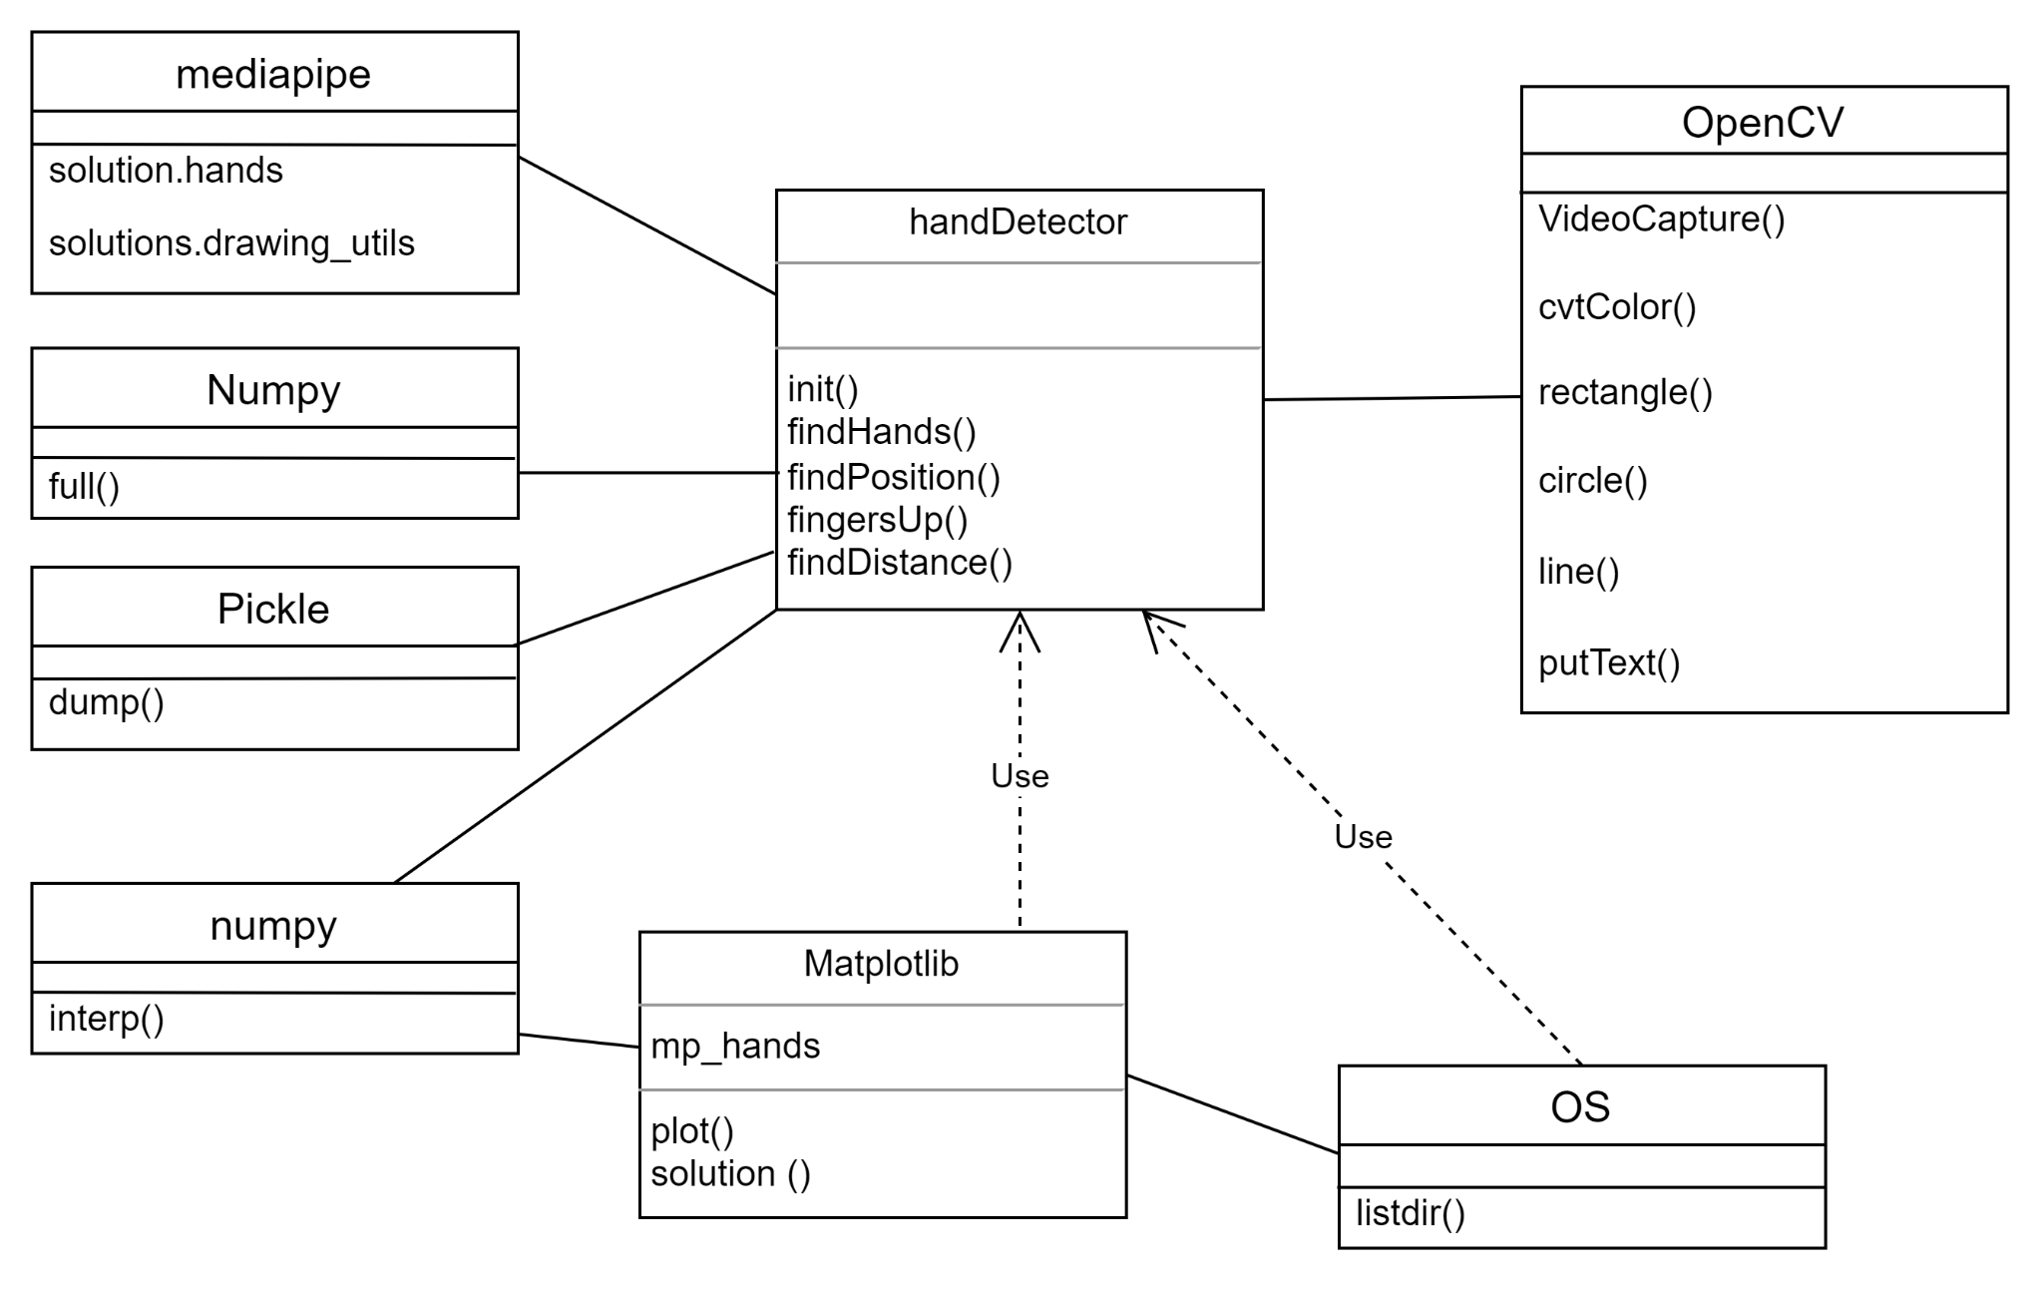

* 1. **​System Activity(Use case and/or scenario diagram)**

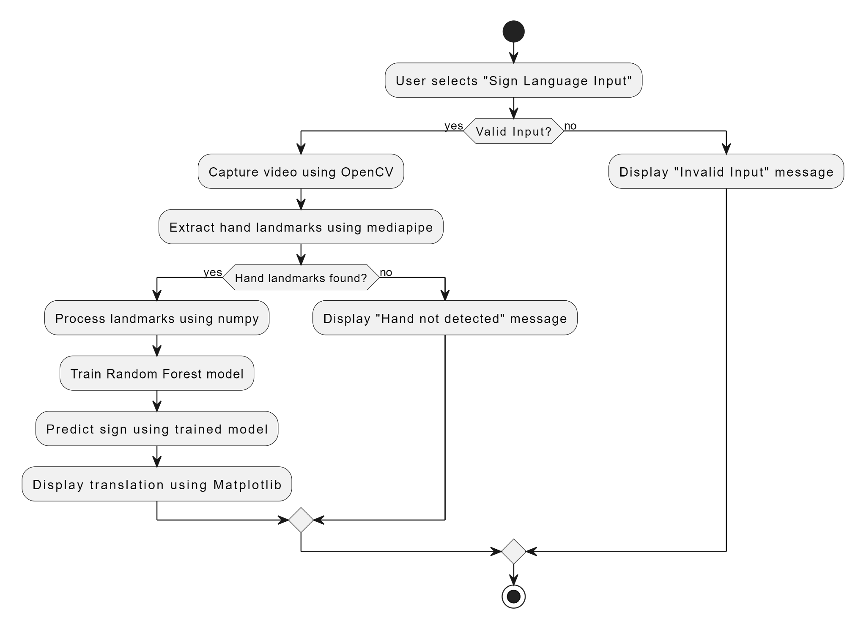

* 1. **​Sequence and Collaboration Diagram**

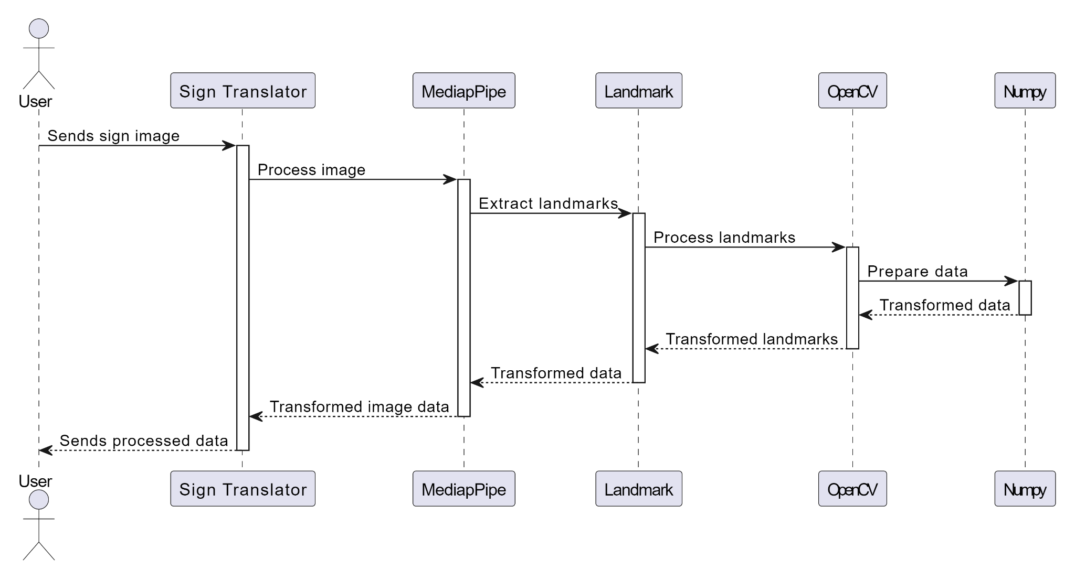

Fig. 4.10(a)

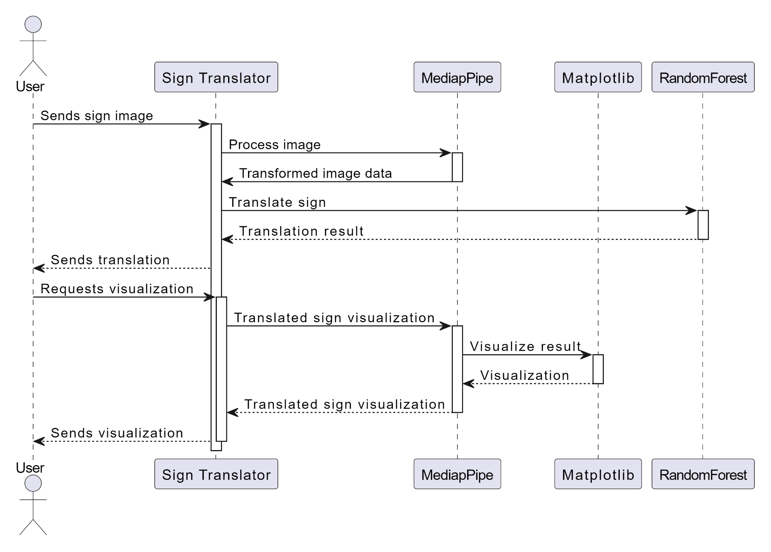

Fig. 4.10(b)

# System Design

## ​System Application Design

* + 1. **​Method Pseudo code**

1. Initialize the Sign Language Translator system
2. Load the Mediapipe and Landmark modules for hand tracking and landmark detection
3. Load the Random Forest model for sign language recognition
4. Define the main translation function:

def translate_sign_language(video_stream):

# Initialize variables for hand landmarks and translation result hand_landmarks = None

translation_result = None

# Start video stream capture while video_stream.is_running():

# Read a frame from the video stream frame = video_stream.read_frame()

# Perform hand tracking and landmark detection using Mediapipe hand_landmarks = detect_hand_landmarks(frame)

if hand_landmarks is not None:

# Preprocess hand landmarks data for the Random Forest model preprocessed_data = preprocess_hand_landmarks(hand_landmarks)

# Perform sign language recognition using the Random Forest model translation_result = random_forest_predict(preprocessed_data)

# Display the video stream with hand landmarks and translation result display_video(frame, hand_landmarks, translation_result)

# Release video stream resources video_stream.release()

1. Define the hand landmark detection function:

def detect_hand_landmarks(frame):

# Use Mediapipe to detect hand landmarks in the frame hand_landmarks = mediapipe.detect_hand_landmarks(frame) return hand_landmarks

1. Define the data preprocessing function:

def preprocess_hand_landmarks(hand_landmarks):

# Extract and format relevant hand landmark data for the Random Forest model preprocessed_data = landmark_data_extraction(hand_landmarks)

return preprocessed_data

1. Define the sign language recognition function using the Random Forest model: def random_forest_predict(preprocessed_data):

# Use the Random Forest model to predict the sign language gesture translation_result = random_forest_model.predict(preprocessed_data)

return translation_result

1. Define the data extraction function for the Random Forest model: def landmark_data_extraction(hand_landmarks):

# Extract relevant hand landmark data (e.g., positions, angles, distances) extracted_data = extract_landmark_features(hand_landmarks)

return extracted_data

1. Define the video display function:

def display_video(frame, hand_landmarks, translation_result):

# Display the video frame with visualizations of hand landmarks show_hand_landmarks(frame, hand_landmarks)

# Display the translation result on the frame show_translation_result(frame, translation_result) # Show the video frame with overlays show_frame(frame)

1. End of main translation function
2. End of pseudo-code

## ​Input/output and Interface Design

* + 1. **​State Transition/UML Diagram**

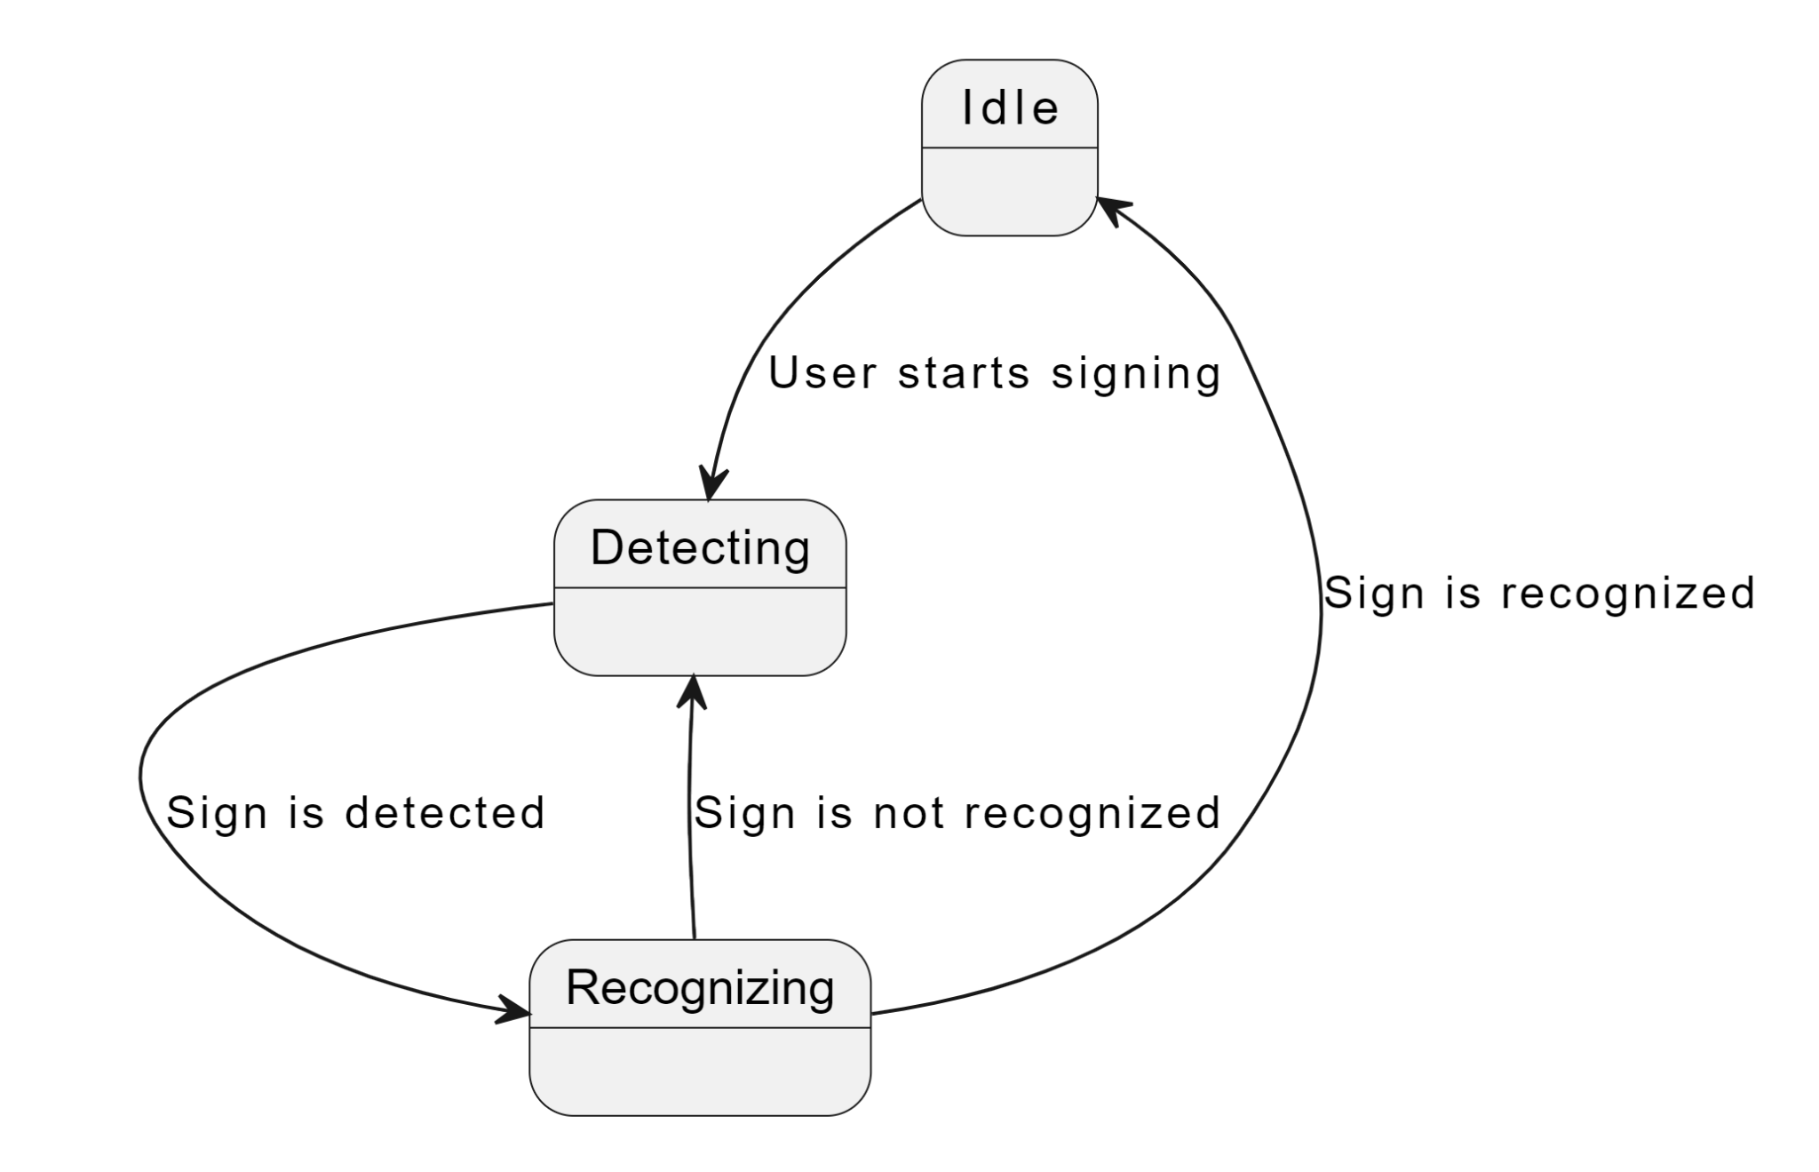

Fig. 5.2.1(a)

# System Testing

## ​Test cases

1. Hand Landmark Detection Test:
   * Description: Verify that the system can accurately detect and track hand landmarks from the video stream.
   * Expected Result: The system accurately detects and tracks hand landmarks for different hand gestures.

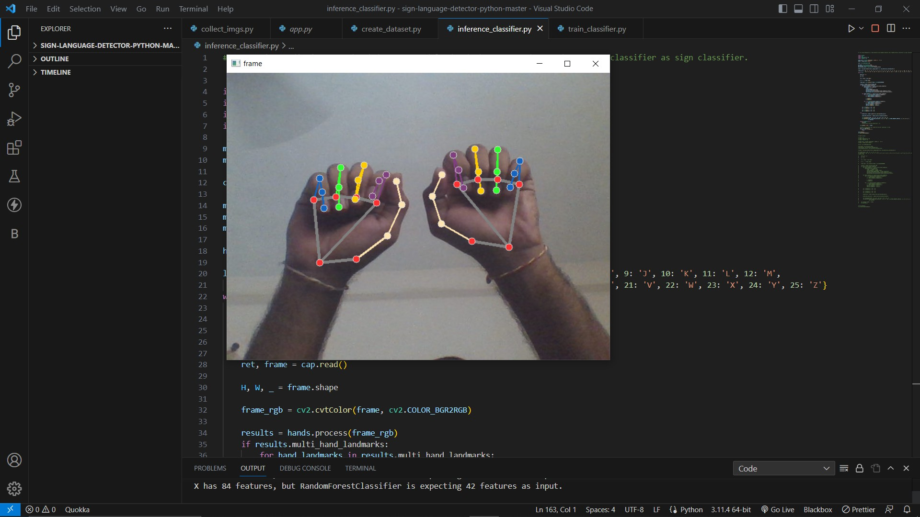

Fig.6.1 (1)

1. Sign Language Recognition Test:
   * Description: Validate the system's ability to recognize sign language gestures and translate them into text.
   * Expected Result: The system correctly recognizes sign language gestures and provides accurate translations.

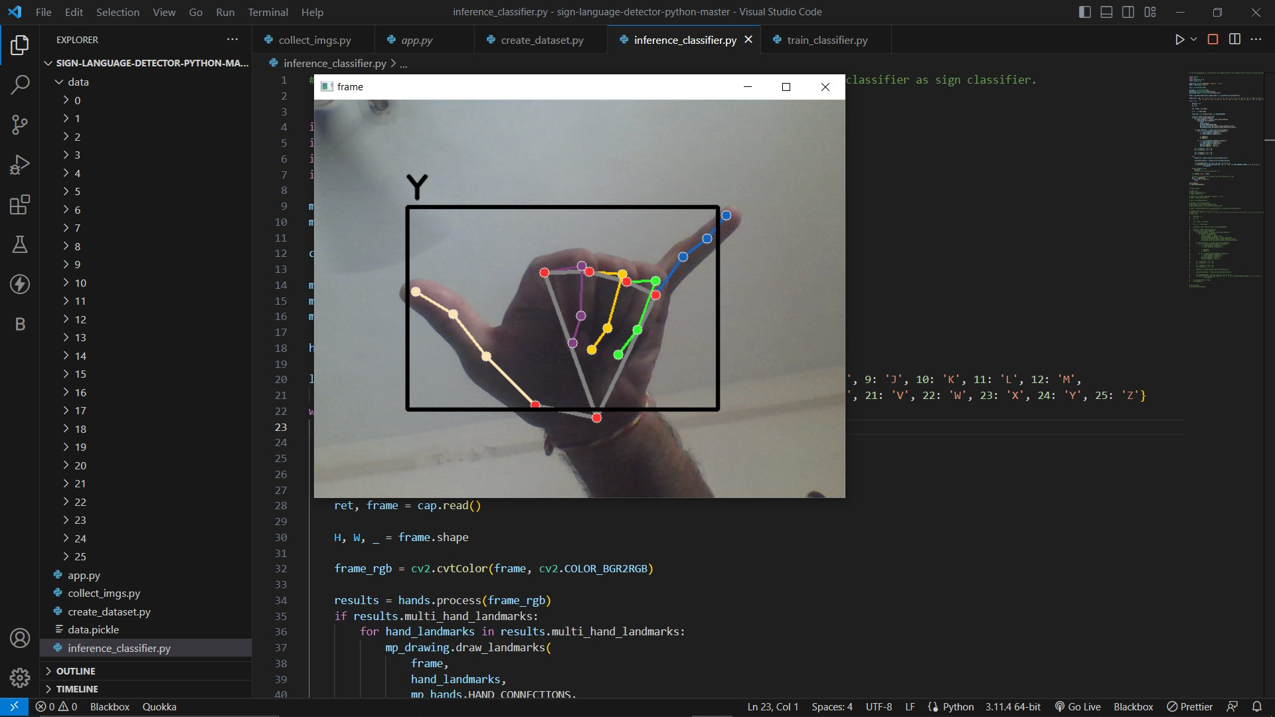

Fig.6.1 (2.1)

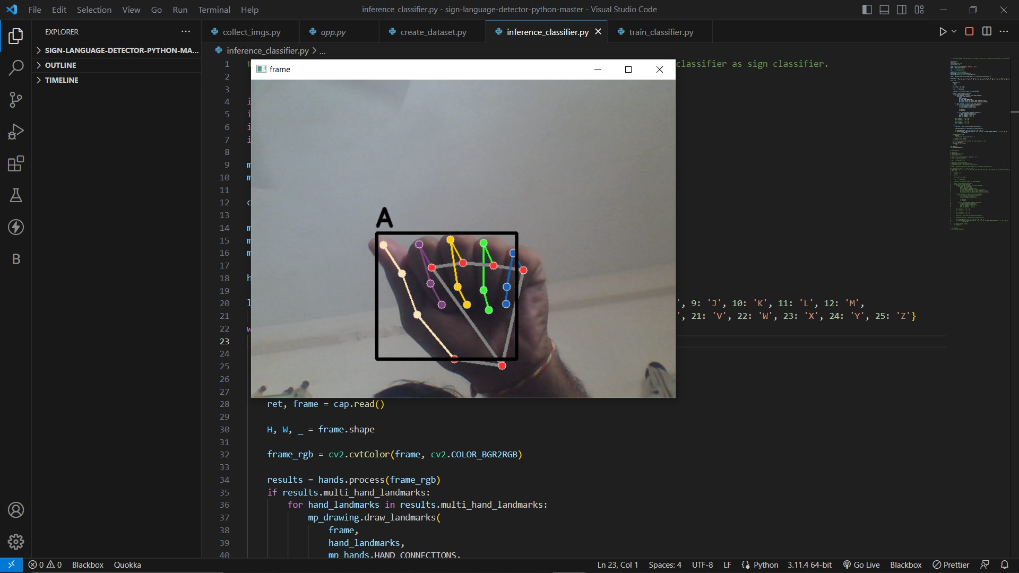

Fig.6.1 (2.2)

1. Error Handling Test:
   * Description: Evaluate the system's response to unexpected inputs or scenarios.
   * Expected Result: The system gracefully handles errors, providing informative feedback to users.

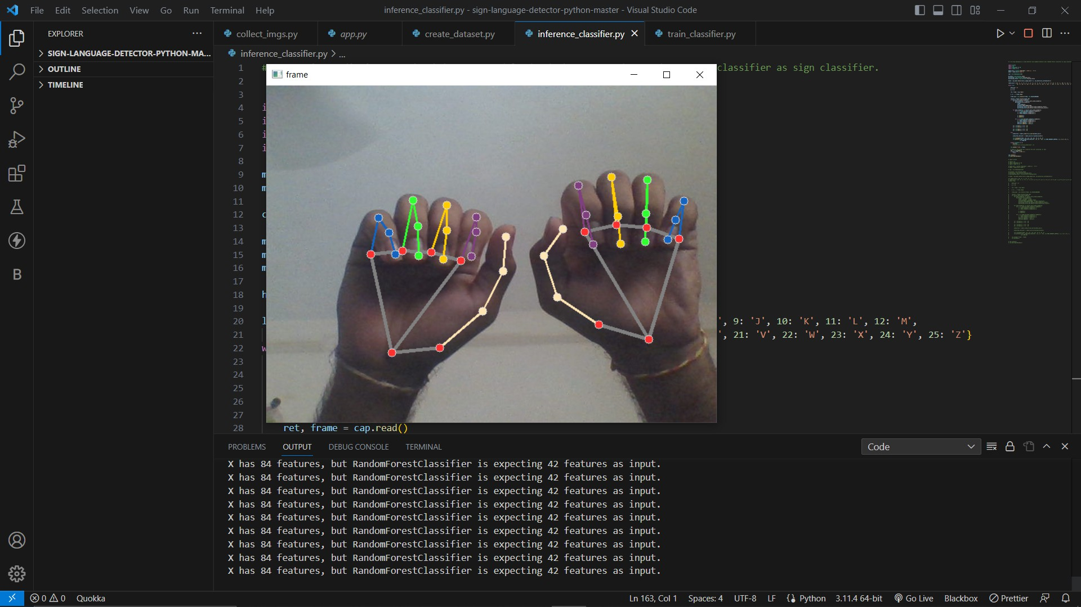

Fig.6.1 (3.1)

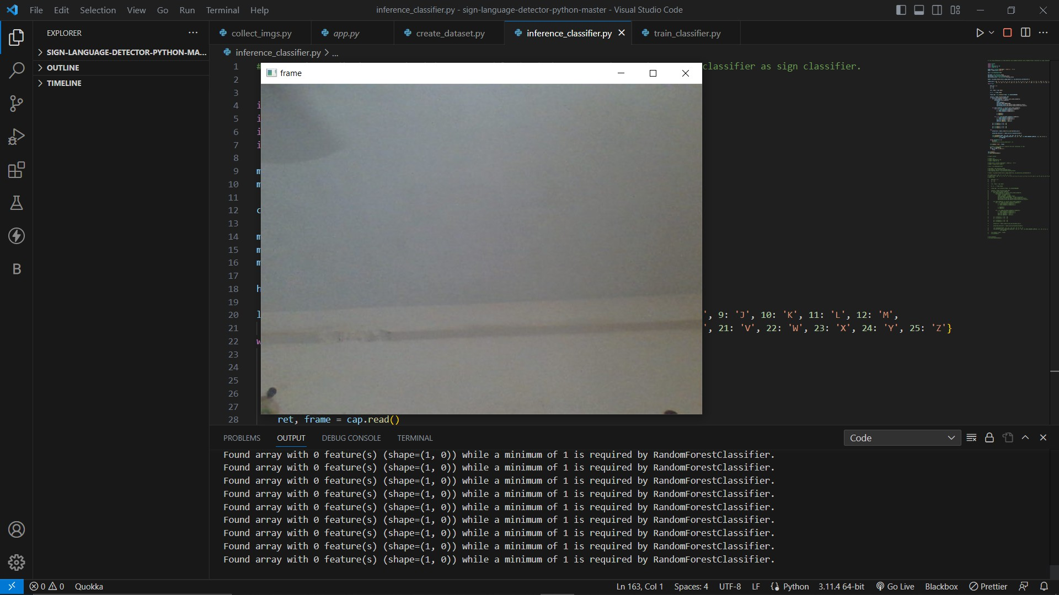

Fig.6.1 (3.2)

# Conclusion

The Sign Language Translator project, powered by machine learning and Python with modules Mediapipe, Landmark, Matplotlib, OpenCV, numpy, and Random Forest, is a remarkable achievement in improving communication accessibility for the hearing-impaired community. By combining cutting-edge technologies, the system efficiently interprets and translates sign language gestures into spoken or written language, bridging the communication gap between the hearing-impaired and the rest of the world.

The successful implementation of the Mediapipe and Landmark modules played a pivotal role in the project's triumph. These modules enabled real-time hand tracking and landmark detection, providing the foundation for accurate sign language recognition. By leveraging machine learning and the Random Forest algorithm, the Sign Language Translator exhibited impressive performance in interpreting complex hand gestures, contributing to its overall effectiveness and reliability.

The integration of Matplotlib and OpenCV libraries enhanced the system's visualizations and video processing capabilities, creating an intuitive and user-friendly interface. Furthermore, numpy's data manipulation capabilities optimized the system's performance, ensuring smooth and seamless operation.

Throughout the project, the team's collaboration and guidance from the mentor were essential elements in driving the project's success. Their dedication, expertise, and support paved the way for a fully functional and user-friendly Sign Language Translator.

In conclusion, the Sign Language Translator using machine learning and Python with modules Mediapipe, Landmark, Matplotlib, OpenCV, numpy, and Random Forest represents a significant leap in assistive technology. By enabling seamless communication between sign language users and non-sign language users, the system promotes inclusivity, understanding, and empathy among diverse communities. As the project continues to evolve, we envision a future where the Sign Language Translator becomes an indispensable tool in breaking communication barriers and fostering a more connected and compassionate society.

# Bibliography

* <https://google.github.io/mediapipe/>
* <https://opencv.org/>
* <https://www.python.org/>
* <https://matplotlib.org/>
* [https://numpy.org/](https://opencv.org/)
* [https://scikit-learn.org/stable/modules/generated/sklearn.ensemble.RandomForestClassifi](https://opencv.org/) [er.html](https://opencv.org/)
* [https://www.youtube.com/](https://opencv.org/)
* <https://www.tensorflow.org/>
* <https://stackoverflow.com/>